

**FIRST YEAR DIPLOMA ENGINERING (I - SCHEME)**

**A**

**MICRO PROJECT**

**“Website for Indian Cricket”**

**SUBMITTED BY**

**1. Mr. Patil Pratik Kumar**

**ADVISOR**

**Miss. Pathan I.H.**

**(DEPARTMENT OF COMPUTER ENGINEERING)**

***CERTIFICATE***

This is to certify that, as part of the partial fulfillment of the Three Years Diploma Course for the semester second, the bonafide students studying in First Year Diploma(Computer Engineering)., I Scheme , Mr. Patil Pratik Kumar, Mr. Bhawar Adesh Manohar, Mr. Patil Aditya Bapuso, Mr. Pandit Shubham Dattatray, Mr. Mulani Adam Ahemad, Miss. Malame Alka Gajanan, Miss. Jadhav Nilam Sampatrao, Miss. Deshmukh Vaishnavi Shivaji, Miss. Suryawanshi Sakshi Santosh , Miss. Jagtap Sakshi Krishna.

have completed the project report titled as,“ **Website for Indian Cricket**” For the subject –Web Page Designing with HTML (22014) under the guidance of Miss. Pathan I.H. and submitted it to Govt. Polytechnic Karad. The information presented in this project report has not been submitted earlier.

**Miss. Pathan I.H. Miss. S. B. Patil**

**(GUIDE)** **Head of Department**

Date:24 /03 /2018

Place: Govt. Polytechnic, Karad

**ACKNOWLEDGEMENT**

We take it is an opportunity to thank all those who have directly and indirectly inspired, directed and assisted us towards successful completion of this project report.

We express our sincere thanks to the Principal, Dr. Prof. V.S. Bandal & the Head of Department, Ms. S. B. Patil for having us allowed to submit this report as part of our academics learning.

We express our sincere thanks to Mr. Pathan I.H*,* Lecturer in Computer Engineering, Department of Computer Engineering , Govt. Polytechnic Karad for encouragement throughout the project report and guideline in designing & working out this project.

We are also grateful to team of project named as “**Website for Indian Cricket**” for their highly encouraging and co-operative attitude. We express our sense of gratitude towards our friend and parents for their constant moral support during project report.

Place: Govt. Polytechnic, Karad

Date: 24/ 03/2018

Yours Sincerely,

**Mr. Patil Pratik Kumar**

**INDEX**

|  |  |
| --- | --- |
| **Sr. No.** | **Content** |
| 1. | Introduction |
| 2. | Features of project |
| 3. | Code |
| 4. | Output (screenshot) |
| 5. | Conclusion |

**Introduction**

Indian Cricket team is one of the excellent cricket team in the world. Its the heart of Indians. From 1932, since India made his international debut Indian players have given their best performance in the field of Cricket. Indians women’s​ are also playing an important role in cricket. This website is dedicated to such Indian cricket heroes.

We have made some sections in our website. We have linked them internally. Following are the sections of the website:

* Home: It includes general information of cricket.
* Gallery: It contains some images of Indian cricket.
* History: It includes all the history of the Indian Cricket.
* Domestic cricket: It contains information of cricket played in India. It also include information about trophy’s which are played in India
* International Cricket: In includes information about Indian Cricket team at international level.
* Women’s Cricket: It includes information about of women’s Cricket.
* general records of Indian Cricket.
* Players Profile: It includes info some important players
* Contact: It contains our contacts.

**Features of the project**

The features of project on “Website for Indian cricket” are

1. The website describes the details of Indian cricket.
2. It contains important images of Indian cricket which had created history.
3. It also include history of Indian cricket before independence and after independence.
4. The website includes general information and history of Indian women’s cricket.
5. The website includes the information of domestic cricket which is played in India throughout the year.
6. The website describes the profiles of the Indian cricket players.
7. The Website contains records of Indian Cricket.

**Output of Website (Screenshots)**

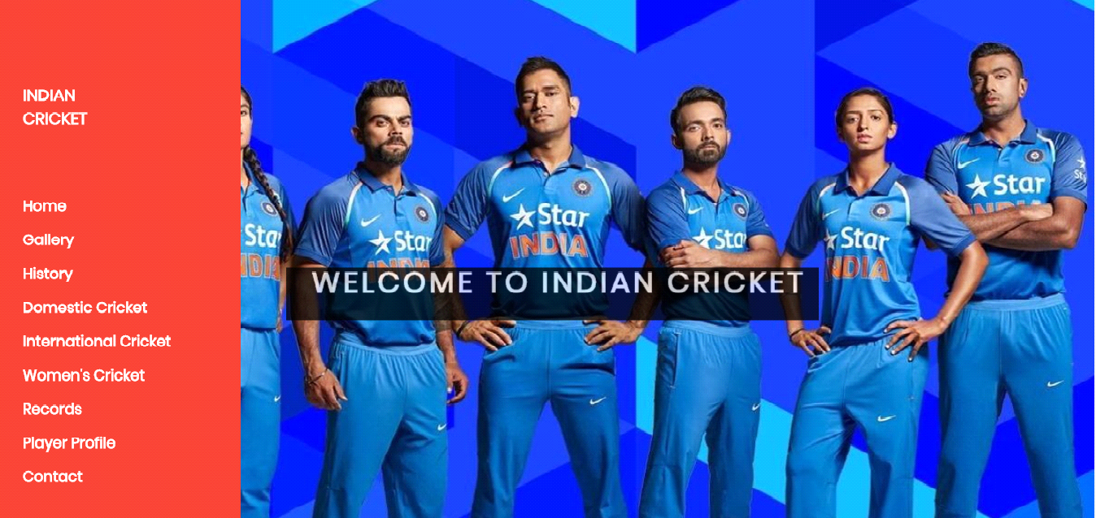

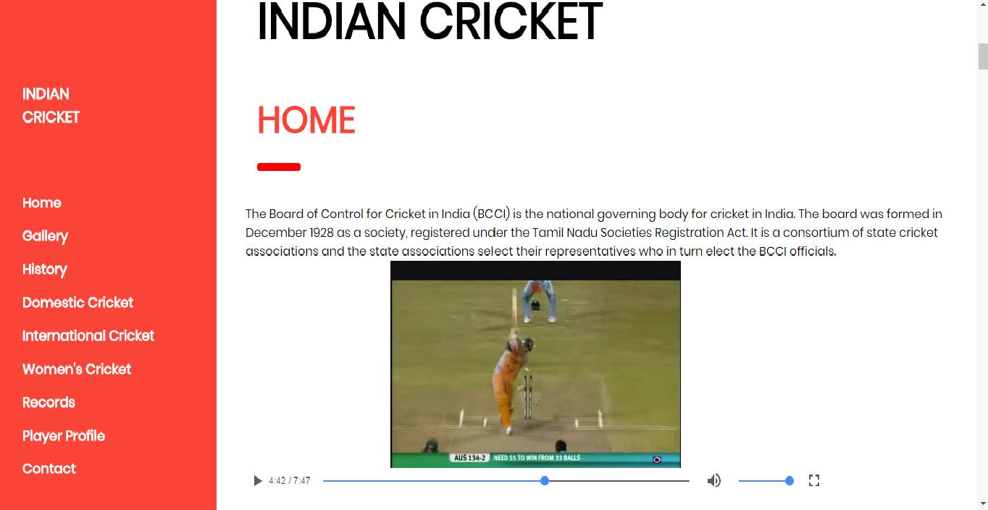

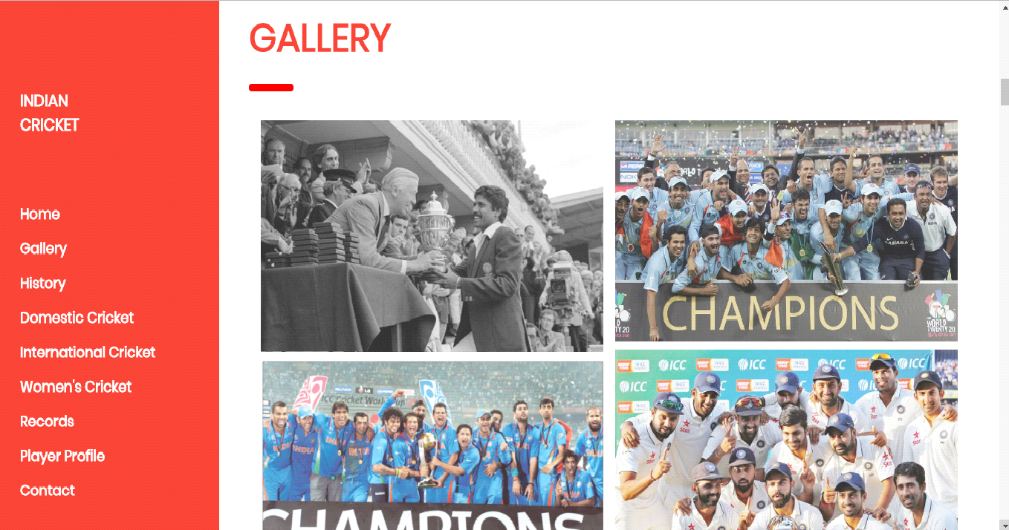

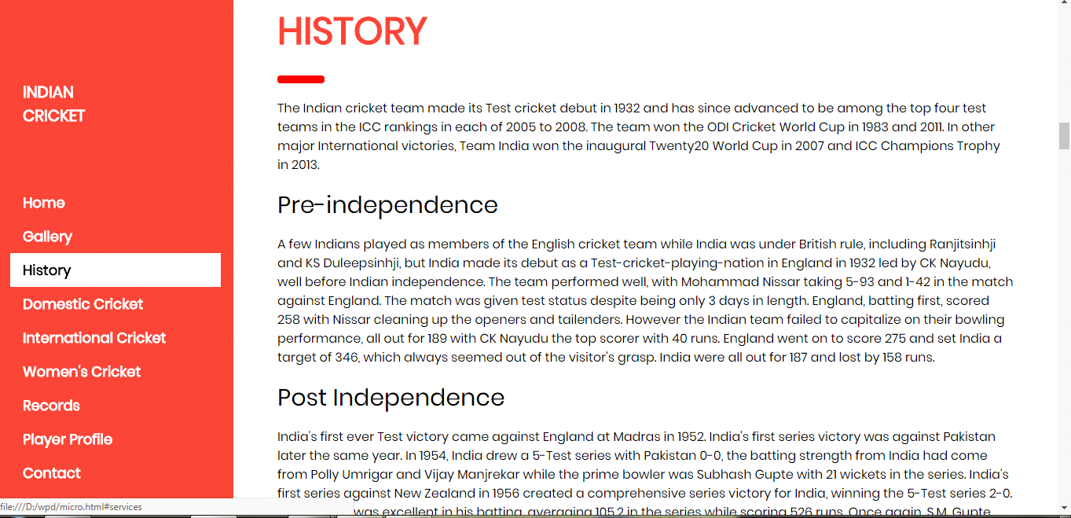

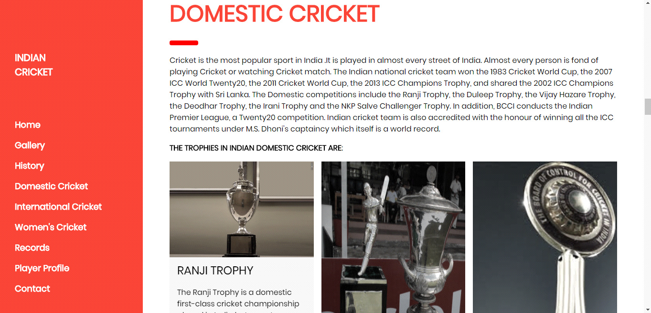

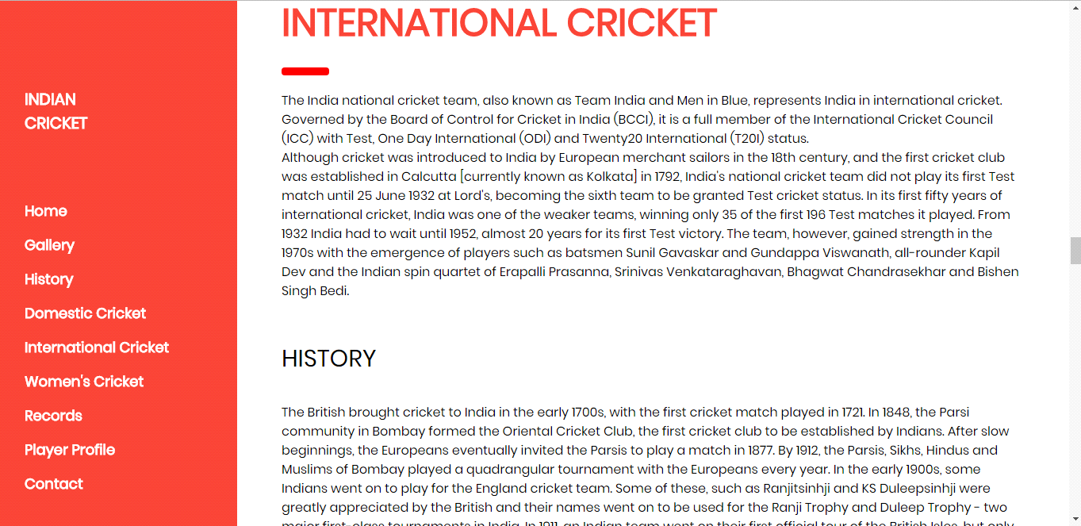

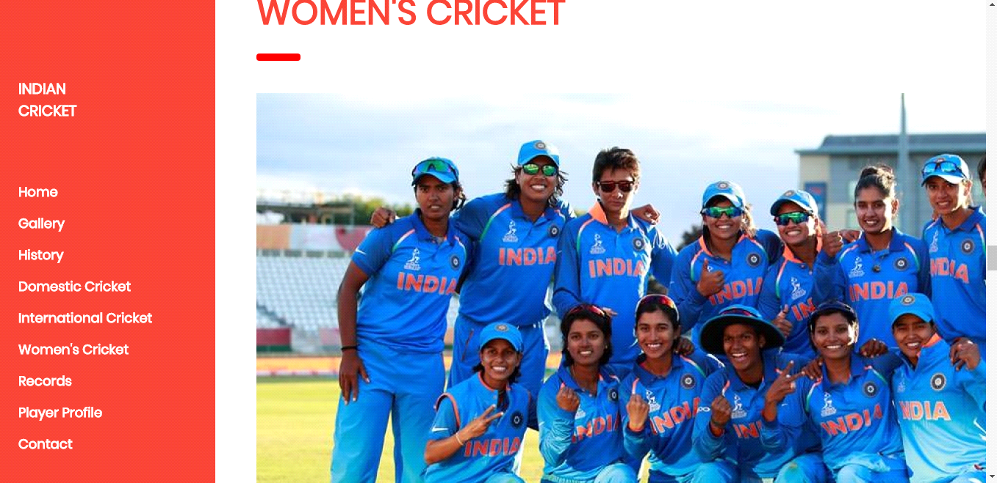

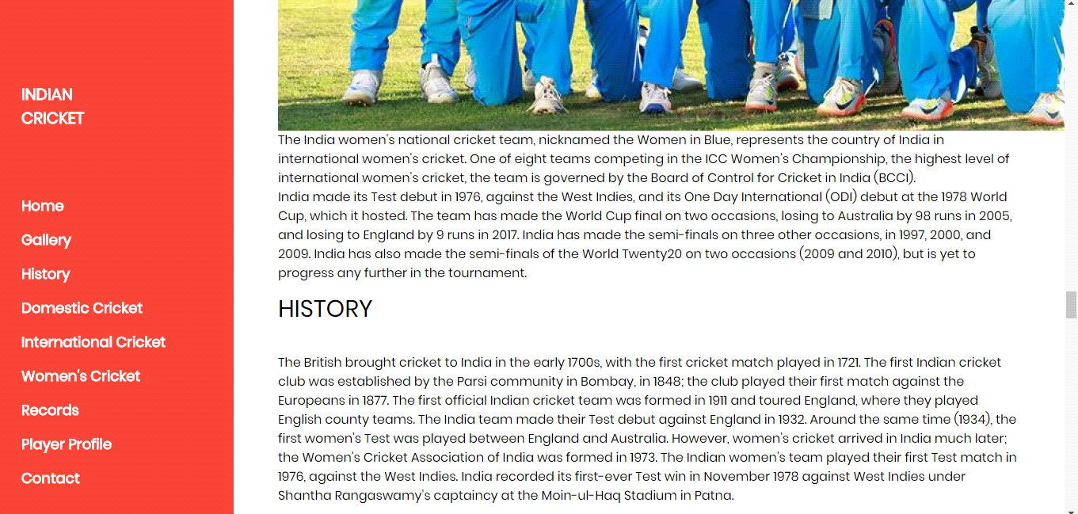

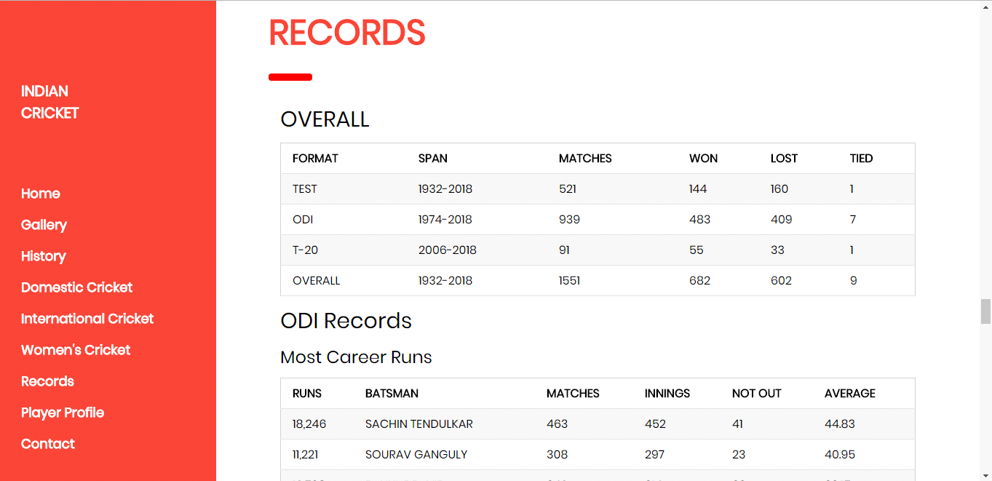

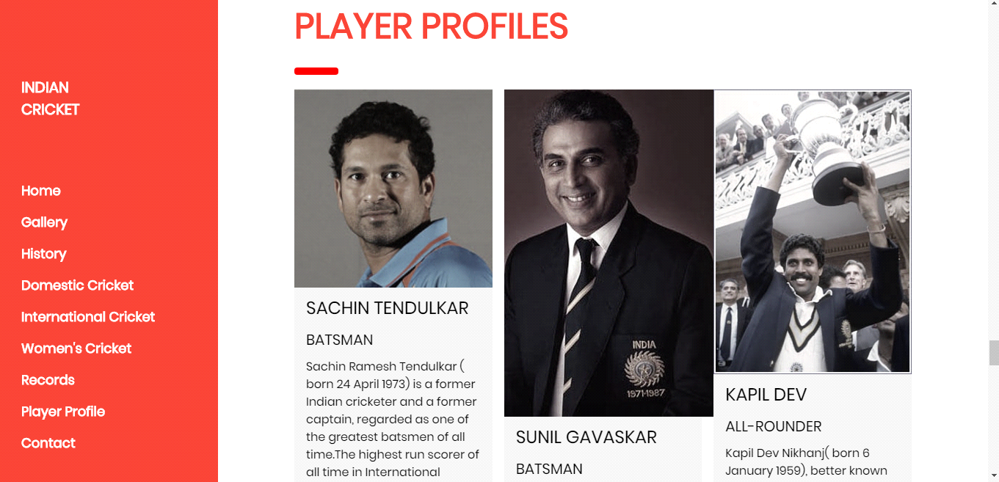

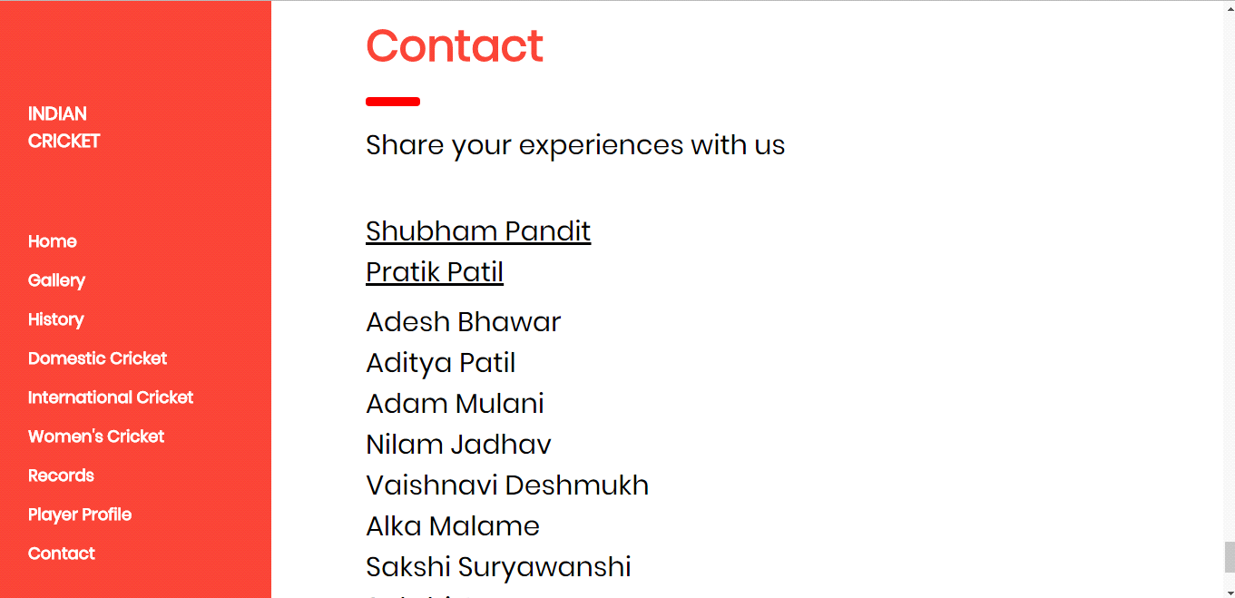

**Conclusion**

From this project, we learnt the HTML language and CSS which is used for making the webpages. The concept of Internal Linking tag and hyperlinking was understood by us. We studied to insert the images and video.

From this project we learnt to work in group. We gathered together and made this website. It was the great experience for all of us.